CPS Re-analsyis

Predator dataset:

Response: Presence/Absence data

Variables:

Year: Random, factor, 1998-2002

Month: factor, May-Aug

Temperature: continuous, z scored (subtract mean and divide by sd)

Salinity: continuous, z scored

Distance to shore (m): continuous, z scored

Latitude: factor, “above” and “below” mouth of CR (samples were not taken across range of latitudes but rather clumped together either above or below the mouth of the CR)

Model: P/A ~ ztemp*Month+zsal*Month+Lat*Month+zDTS*Month+(1|Yr_fac)

Link: binomial

RESULTS:

Northern Anchovy:

Signifncat difference above and below CR in June

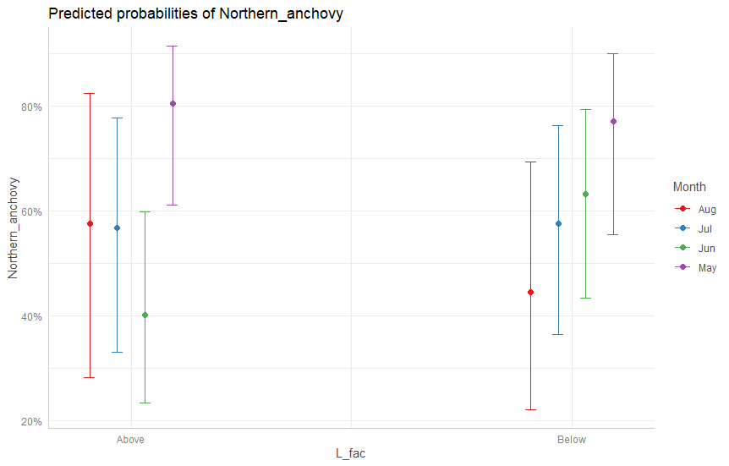

More likely to catch NoAn closer to shore in May and June. Differences in magnitude above and below CR

Above

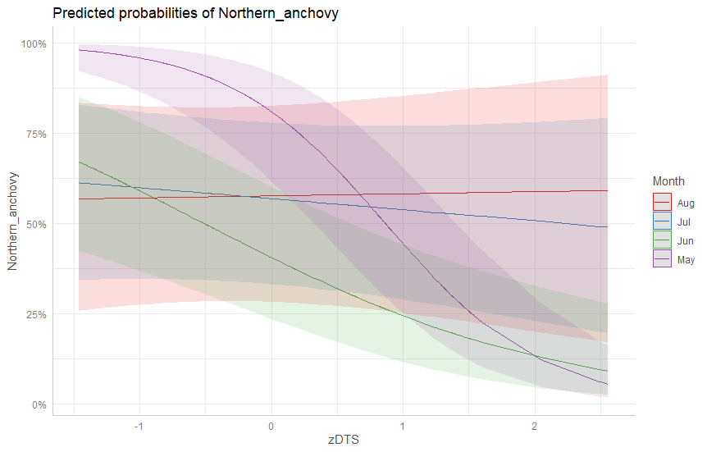

Below

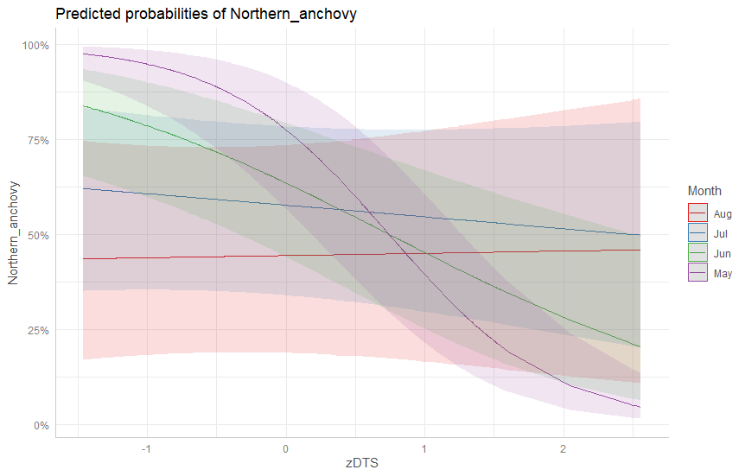

More likely to cath NoAn in warmer water in May and June

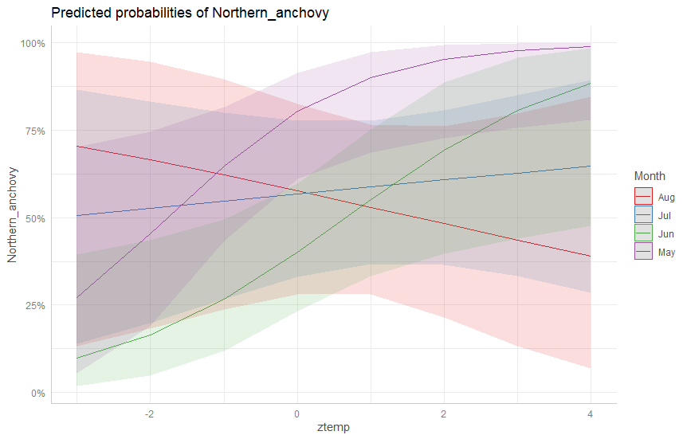

Pacific Sardine:

More ikely to catch sardine further from shore. Opposite true in may but presenc realtively low during May

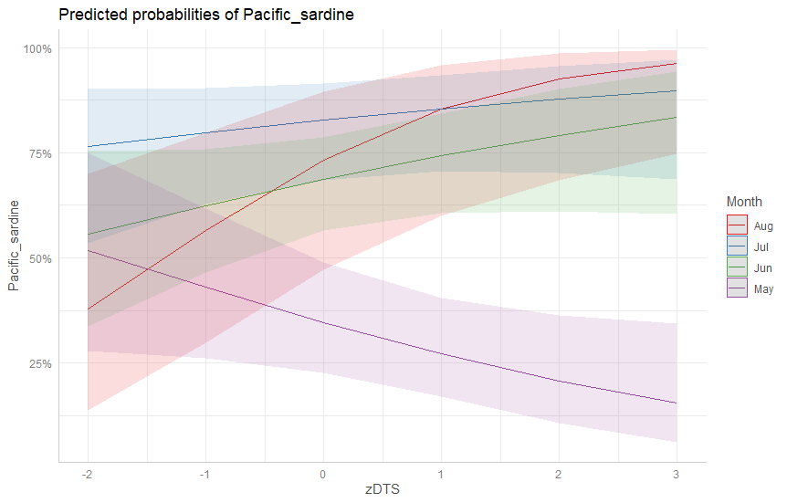

Temp had relatively little effect on PaSd presence except in month of May

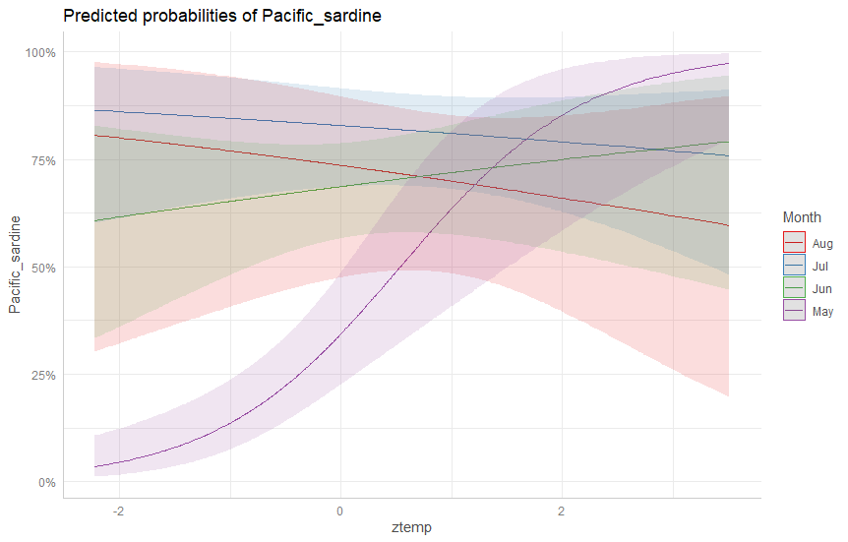

Presence of PaSd went down with increasing salinity in all months except May

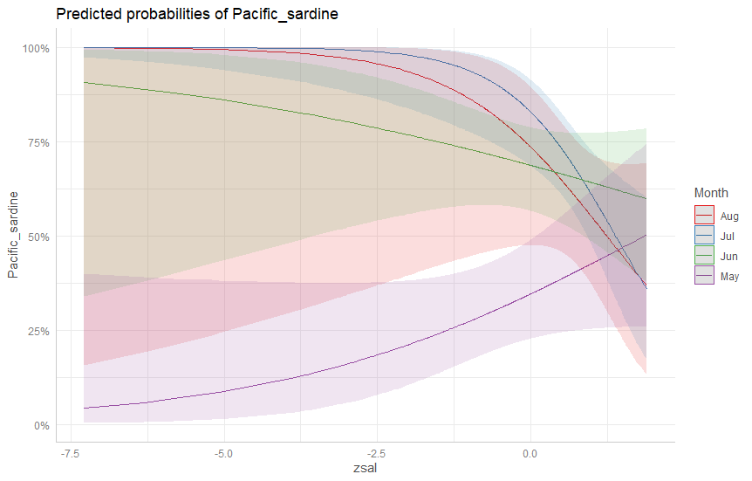

Pacific Chub Mackerel:

PaMa were relatively sparse in all months except August and were more likely in waters further offshore

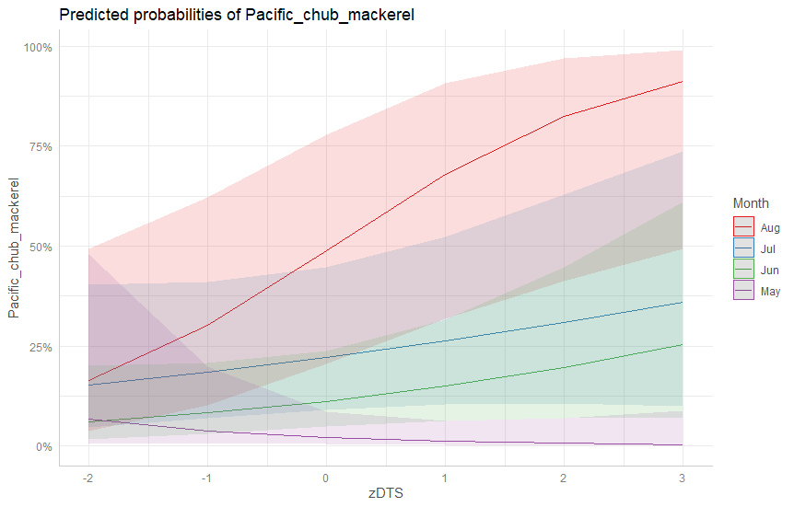

Jack Mackerel:

JaMa were captured relatively infrequently but probability presence increased from May to Aug. JaMa were more likely offshore than nshore.

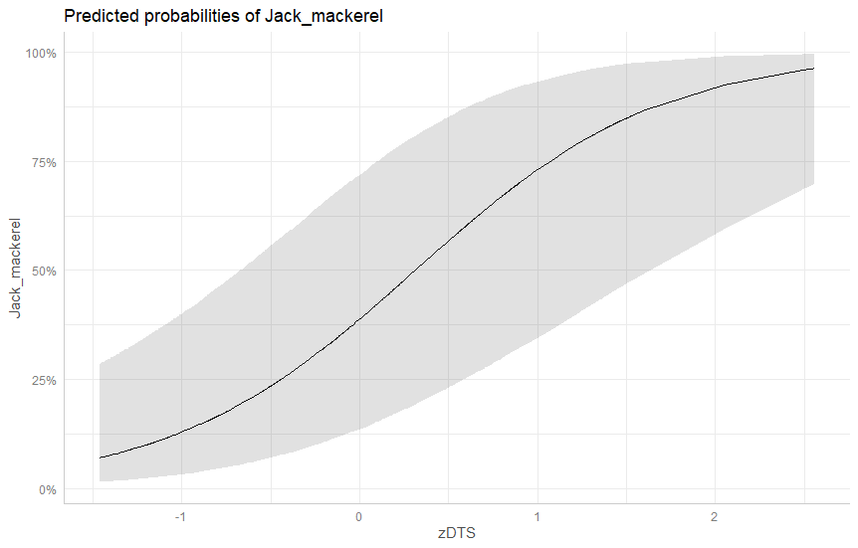

Market Squid:

MASq were most likely present in in shore waters during May and June and moved offshore in Aug

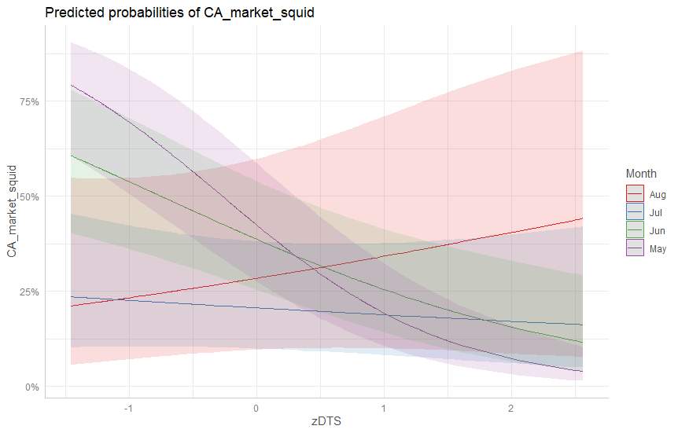

MaSq presence positively correlated with temp in June and July and negatively correlated with temp in May and Aug.

